Solution of Machine Design Problems

Problem #M_{1c}: A 1”-12 UNF steel bolt of SAE grade 5 is under direct shear loading. The coefficient of friction between mating surfaces is 0.4. The bolt is tightened to its full proof strength. Tensile area is 0.663 in² Proof strength is 85 kpsi, and yield strength is 92 kpsi
- What shear force would the friction carry?
- What shear load can the bolt withstand w/o yielding if the friction between clamped members is completely lost? Base the calculation on the thread root area.

Data for this bolt:
A_{t}=0.663 in² S_{p}=85000 psi S_{y}=92000 psi
The initial load in the bolt is:
F_{i}=A_{t}S_{p}=.663(85000)=56355 lbs
The friction force
F_{f}=μF_{i} = 0.4(56355)=22542 lbs
The direct shear stress force w/o yielding is:
F_{s} = 2A_{t}(S_{ys})=2A_{t}(0.58S_{y})=2(0.663)(0.58)(92000)=70740 lbs
If the bolt is subject to shear in the shank area, then use the larger shank area.

Problem #M₃

Assuming a rigid bracket, the top bolts elongate or strain 3 times more than the lower bolts. Taking moments about the pivot point we get:
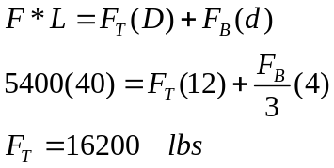

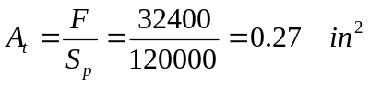The load per bolt is half of this amount or 8100 lbs. Incorporating a factor of safety of 4, the design load per bolt is 4(8100)=32400 lbs. The required tensile area for each bolt is:
The appropriate bolt is a Grade 8 ¾ “ –10 UNC

Problem #M4
L

The bolts are ½”-13UNC. The distance between bolts is 1.25”. The load is 2700 lbs and L=8”. Find the shear stress on each bolt.

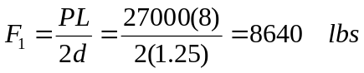The torsional shear force (balancing the force couple) is:
The direct shear stress
The 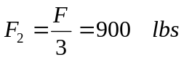total force is:
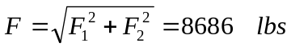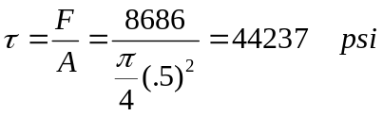The shear stress in each bolt using the shank diameter is:

Exercise # M1 : A pair of spur gears with a pitch of 6 are in mesh. The pinion has 18 teeth and rotates at 1800 rpm transmitting 0.5 Hp. Both gears have 20-degree pressure angles. The number of teeth on the gear is 36. Determine the radial and tangential forces on the pinion.

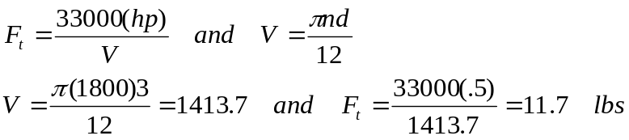

The radial force is:

Exercise # M2: A pair of helical gears transmit 15 KW power and the pinion is rotating at 1000 rpm. The helix angle is 0.50 radians and the normal pressure angle is 0.35 radians. The pitch diameter of the pinion is 70 mm and the pitch diameter of the gear is 210 mm. Determine the tangential, radial, and axial forces between the gear teeth. (Answers: 4092, 1702, 2236 Newtons)

The tangential load is determined from the power relationship. The relationship in SI units uses the driving torque:
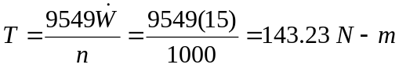
where the power is in Kw. The tangential load creating this torque is:
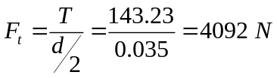
The radial and axial forces are:
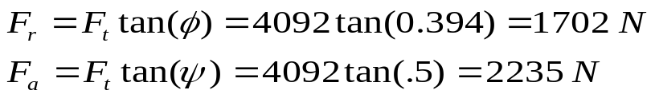
Note that:
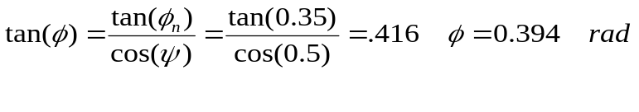
Exercise #M3: A pair of straight-tooth bevel gears (as shown in the figure above) are in mesh transmitting 35 hp at 1000 rpm (pinion speed). The gear rotates at 400 rpm. The gear system has a pitch of 6 and a 20-degree pressure angle. The face width is 2 inches and the pinion has 36 teeth. Determine the tangential, radial, and axial forces acting on the pinion. Answers (839 lbs, 283 lbs, 113 lbs).
d
d_{avg}
b
γ
From the gear geometric information:
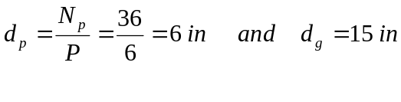
The pitch cone angle can be obtained from the ratio of pitch diameters.
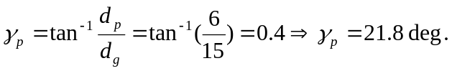
From geometry, the average diameter of the pinion is:
The pinion’s average pitch-line velocity is:
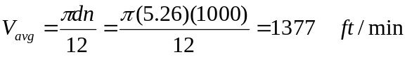
Now we can find the tangential force :
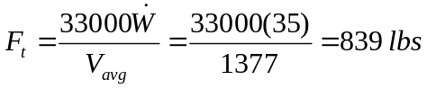
The axial and radial forces are:
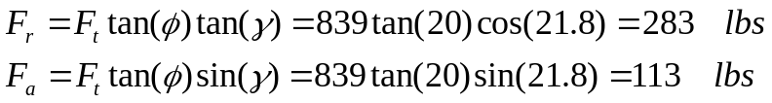
Exercise #M4: A worm gear reducer is driven by a 1200 rpm motor. The worm has 3 threads and the gear has 45 teeth. The circular pitch of the gear is p=0.5”, the center distance is 4.5 inches, the normal pressure angle is 20 degrees, and face-width of the gear is b=1 inch. Use a coefficient of sliding friction of 0.029. Determine:
- Gear and worm diameters, and worm Lead. (7.16, 1.84, 1.5 in)
- The worm gear efficiency (88.6%)
- Is the unit self-locking (No)

The gear pitch diameter can be found from the number of teeth and its circular pitch:
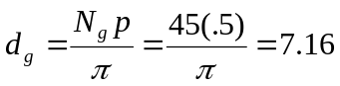
The pitch diameter of the worm can be obtained from the center distance and the pitch diameter of the gear:
The lead is the number of threads in the worm times the worm’s axial pitch which is the same as the gear’s circular pitch:
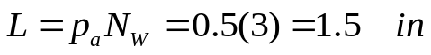
The gear efficiency can be obtained knowing the sliding friction as well as the normal pressure angle and the lead angle of the worm. The lead angle of the worm is:
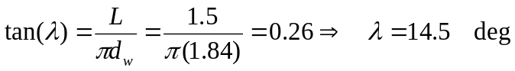
The efficiency:
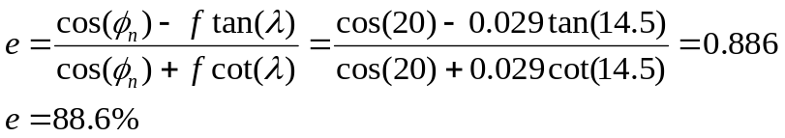
The gear set is overhauling (reversible) because the friction coefficient f=0.029 is less than that required for locking which is:

Problem M #7: A 10”-wide flat belt is used with a driving pulley of diameter 16” and a driven pulley of rim diameter 36” in an open configuration. The center distance between the two pulleys is 15 feet. The friction coefficient between the belt and the pulley is 0.80. The belt speed is required to be 3600 ft/min. The belts are initially tensioned to 544 lbs. Determine the following. (answers are in parentheses):
Belt engagement angle on the smaller pulley (3.03 radians).
Force in belt in the tight side just before slippage. (1000 lbs).
Maximum transmitted Hp. (99.4 hp)
The engagement angle is:
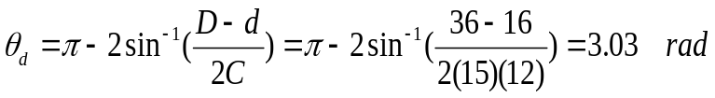
At the verge of slippage:
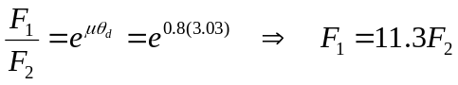
Also:
The transmitted Hp is:
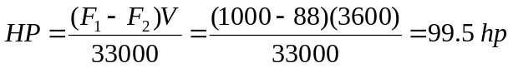

Problem #M₈

Given: A multi-plate disk clutch
d=0.5”
D=6”
P_{max}=100 psi
Coefficient of friction=0.1
Power transmitted= 15 hp at 1500 rpm
Find: Number of friction surfaces

Required Torque Capacity for uniform wear
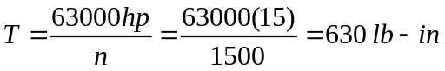
Torque capacity per surface
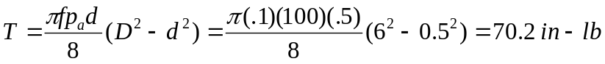
The required number of surfaces is 630/70.2 which is approximately 9 surfaces.

For uniform pressure brake pads (when they are new):
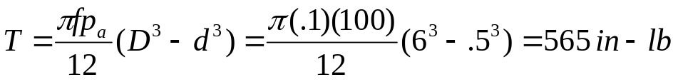

Only two surfaces are needed for constant pressure pads.

Problem #M₉: A brake with braking torque capacity of 230 ft-lb brings a rotational inertia I1 to rest from 1800 rpm in 8 seconds. Determine the rotational inertia. Also, determine the energy dissipated by the brake.

Solution hints:
Convert rpm to rad/sec: ω₁ = 188 rad/sec
Note that ω₂=0
Find the ratio (I₁I₂/I₁+I₂) using time and torque=>9.79
Note that I2 is infinitely large => I1=9.79 slugs-ft
Find energy from equation=>173000 ft-lb

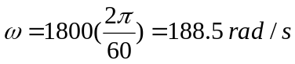
The time to stop is:
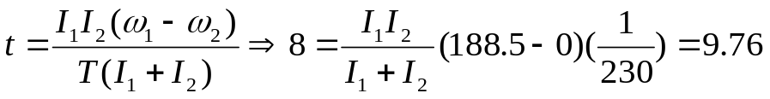
Since I₂>>I₁, we conclude: I₁=9.76 slugs-ft²

The energy is:
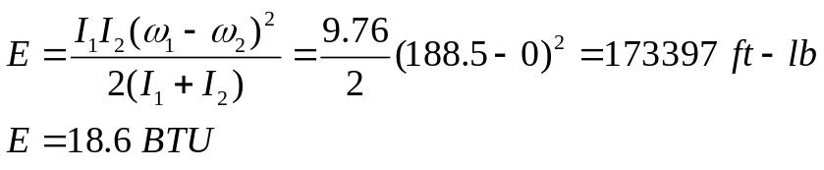

Example #M₁₀: Consider a helical compression spring with the following information (not all are necessarily needed):
Ends: Squared and ground
Spring is not preset
Material: Music wire (steel) with S_{ut}=283 ksi
d=.055 inches and D=0.48 inches
L_{f}=1.36 inches and N_{t}=10

Find the following. Answers are given in parentheses.
Spring constant, K (14.87 lb/in)
Length at minimum working load of 5 lbs (1.02”)
Length at maximum load of 10 lbs (0.69”)
Solid length (0.55”)
Load corresponding to solid length (12.04 lbs)
Clash allowance (0.137”)
Shear stress at solid length (77676 psi)
Surge frequency of the spring (415 Hz)

The spring constant and various lengths:
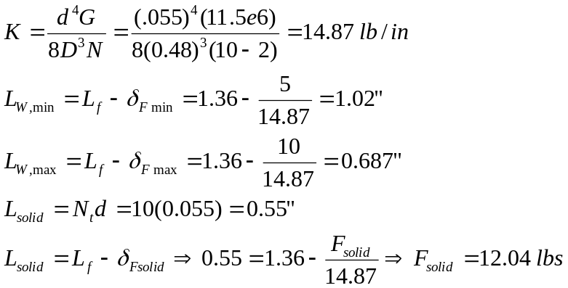

Clash allowance:

Stresses
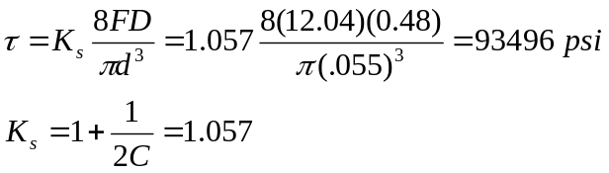
The surge frequency is:
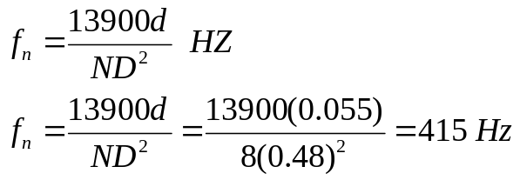

Problem #M12

Application Life
L_{D} = 5000(60)(480) = 1440 million cycles
If the reliability was different than 90%, we divide the application life by the reliability factor. But this problem only asks for 90% reliability.

Application Load
F_{D} = (1.4)(610)(4.45) = 3800 N
Note that one pound is 4.45 Newtons.

Using the Life-Load relationship with application condition on one side and catalog conditions on the other we get:
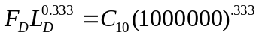
The catalog life rating is based on 1million cycles. Therefore the equivalent capacity for increased life is:
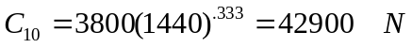

Problem # M13

Major diameter
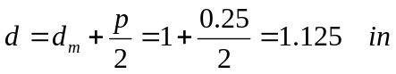
Torque required to lift the load
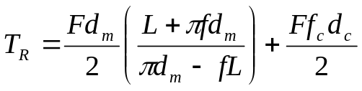
With
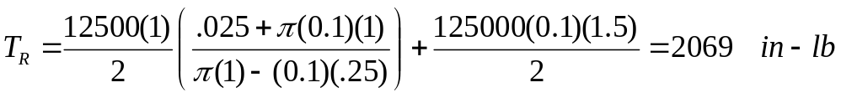

Minimum friction for self-locking
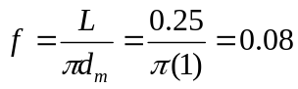
The screw is self-locking. The efficiency:

